**Math Notes for Lab 12**

We can model the flight of an object with the help of *parametric equations*. The equations let us compute the $(x, y)$ position of the object as a function of time $t$, as measured in seconds since the launch from $\left(x_{0}, y_{0}\right)$ at time $t=0$. (So $t$ is the *parameter* used to calculate $x$ and $y$.)

$$x=(v\cos{θ) t+x_{0}}$$

$$y= -\frac{1}{2}gt^{2}+\left(v\sin{θ}\right) t+y_{0}$$

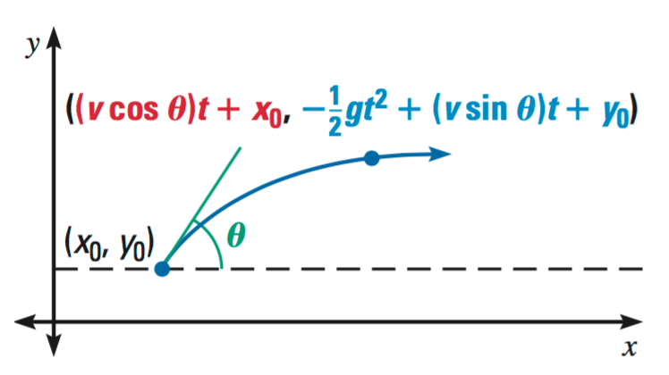

Source: <http://www.classzone.com/eservices/home/pdf/teacher/LA213GAD.pdf>

Some other details you need to know:

* ${(x}_{0}, y_{0})$ is the object's initial position (distance horizontally and vertically from origin).
* $θ$ is the launch angle in radians. Recall that you can convert from degrees to radians by multiplying the number of degrees by $π/180°.$
* $v$ is the launch velocity
* $g$ is the "acceleration" toward by the earth caused by gravity at sea level: 32 feet/sec2 or 9.8 m/s2.
* Note that this model ignores the effect of air resistance.

To calculate these values, you will need to import functions from Python's math module. For example:

from math import sin, cos, pi

(Remember that all import statements should go at the beginning of your code.)